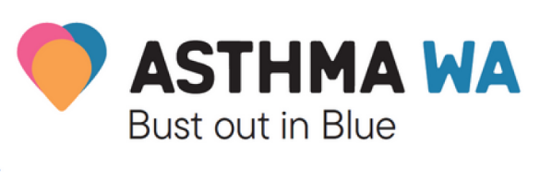

Dear Parents and Caregivers,

On [DATE], [SCHOOL] is going to Bust Out in Blue!

Bust Out in Blue is a fun campaign developed by Asthma WA to help teach our students to be inclusive of and look after their classmates and friends with asthma.

More than 237,000 Western Australians have asthma. Nearly 40,000 people are hospitalised each year in Australia due to asthma with almost half of these being children aged 0-14 years.

Asthma WA is providing our staff with education and training to help us ensure we have the correct skills and procedures in place along with the necessary information to support students with asthma in our school.

Our students will be Busting Out in Blue through a range of activities aiming to increase their awareness of asthma, reduce stigma and promote a culture of safety.

Activities that students will be participating in include:

- Dressing up in blue for the day
- Blue paper aeroplane competition
- Baking blue cakes
- Blue face painting
- Blue fingernail painting
- Arts and crafts with all blue things
- Asthma WA activity Pack
- Putting on a short play about asthma
- Gold coin donation
- [ACTIVITY]
- [ACTIVITY]

To support Asthma WA, we will be inviting students and their families to donate by gold coin or through one of our stalls/activities.

[Donation tin location 1], [Donation tin location 2], [Donation tin location 3], [Donation tin location 4]

Asthma WA is a registered charity and has been providing essential education, support, advocacy and other services for free for 60 years.

